Goal: Implement soft lambda dynamics for 2D cylinder
Dimensions: 15x2 mm, 10 um size, Lambda = 500, tip growth at 5 mm
Logs:
- Debug update: Gencase clean when launched
- Case 3 growth, lambda max at 5 mm, p0, lambda =1000
Closure: Short term behaviour satisfying. Reopening for a more stable / spread rate: 0 at boundary
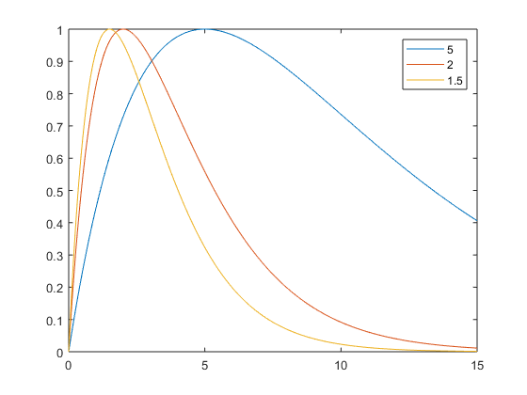
Lx = 1.5 suits the best (warning, divide by 10 to scale the sample 0-1.5 mm)
Logs:
- Build with Lx = 0.15 mm – 5 min computation – 4500 ptcs in 2D
% Redundancy in .o clean command: to be removed
- Stable and steady growth of 0.1 mm
> Confirmation with bigger sample/longer term
- H = 1, width = 0.3, sphere
- short term H0.2: Ok
- H1: very cool data. Meangingful rateDef, stress and growth
- small instability in the cap

